WEEK – 4

Hello World RESTful Web Service

Nipuna

Superset id: 6432842

Write a REST service in the spring learn application created earlier, that returns the text "Hello World!!" using Spring Web Framework. Refer details below:  
  
**Method:** GET  
**URL:** /hello  
**Controller:** com.cognizant.spring-learn.controller.HelloController  
**Method Signature:** public String sayHello()  
**Method Implementation:** return hard coded string "Hello World!!"  
**Sample Request**: http://localhost:8083/hello  
**Sample Response:** Hello World!!   
  
**IMPORTANT NOTE**: Don't forget to include start and end log in the sayHello() method.  
  
Try the URL http://localhost:8083/hello in both chrome browser and   
SME to explain the following aspects:

* In network tab of developer tools show the HTTP header details received
* In postman click on "Headers" tab to view the HTTP header details received

Solution:

1) SpringLearnApplication.java:

package com.cognizant.springlearn;

import org.springframework.boot.SpringApplication;

import org.springframework.boot.autoconfigure.SpringBootApplication;

@SpringBootApplication

public class SpringLearnApplication {

public static void main(String[] args) {

SpringApplication.*run*(SpringLearnApplication.class, args);

}

}

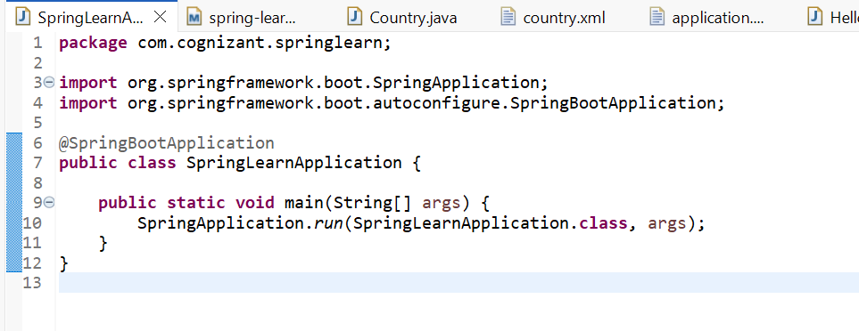

2)Hellocontroller.java:

package com.cognizant.springlearn.controller;

import org.springframework.web.bind.annotation.GetMapping;

import org.springframework.web.bind.annotation.RestController;

@RestController

public class HelloController {

@GetMapping("/hello")

public String sayHello() {

return "Hello World!!";

}

}

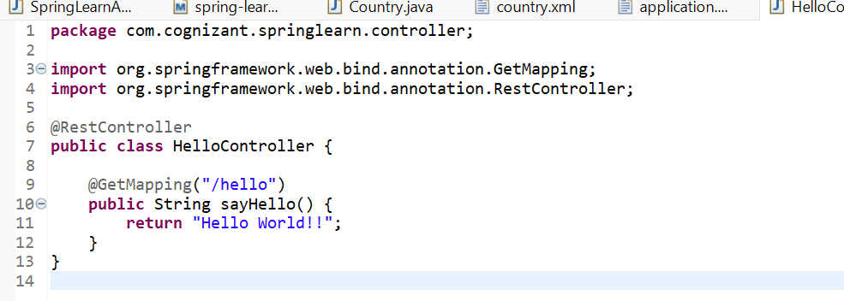

3) pom.xml:

<?xml version="1.0" encoding="UTF-8"?>

<project xmlns="http://maven.apache.org/POM/4.0.0"

xmlns:xsi="http://www.w3.org/2001/XMLSchema-instance"

xsi:schemaLocation="

http://maven.apache.org/POM/4.0.0

http://maven.apache.org/xsd/maven-4.0.0.xsd">

<modelVersion>4.0.0</modelVersion>

<parent>

<!-- Spring Boot brings in Spring, Tomcat, logging, etc. -->

<groupId>org.springframework.boot</groupId>

<artifactId>spring-boot-starter-parent</artifactId>

<version>3.3.0</version> <!-- current LTS as of Jul 2025 -->

<relativePath/> <!-- lookup from Maven Central -->

</parent>

<groupId>com.cognizant</groupId>

<artifactId>spring-learn</artifactId>

<version>0.0.1-SNAPSHOT</version>

<name>spring-learn</name>

<description>Demo Spring Boot REST project</description>

<packaging>jar</packaging>

<properties>

<java.version>17</java.version>

</properties>

<dependencies>

<!-- Web / REST support -->

<dependency>

<groupId>org.springframework.boot</groupId>

<artifactId>spring-boot-starter-web</artifactId>

</dependency>

<!-- Spring Boot test utilities (optional but handy) -->

<dependency>

<groupId>org.springframework.boot</groupId>

<artifactId>spring-boot-starter-test</artifactId>

<scope>test</scope>

</dependency>

</dependencies>

<build>

<plugins>

<!-- Spring Boot repackage plugin -->

<plugin>

<groupId>org.springframework.boot</groupId>

<artifactId>spring-boot-maven-plugin</artifactId>

</plugin>

</plugins>

</build>

</project>

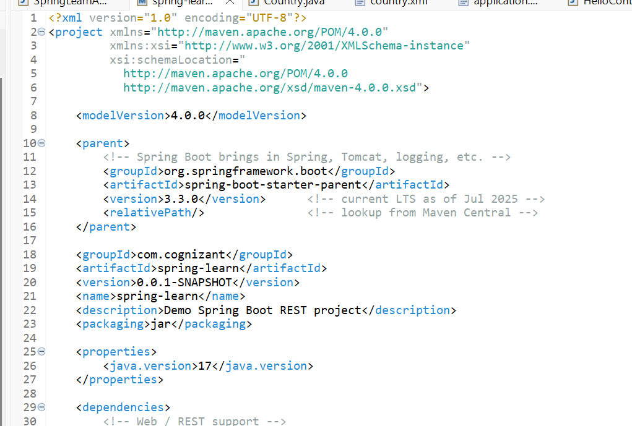

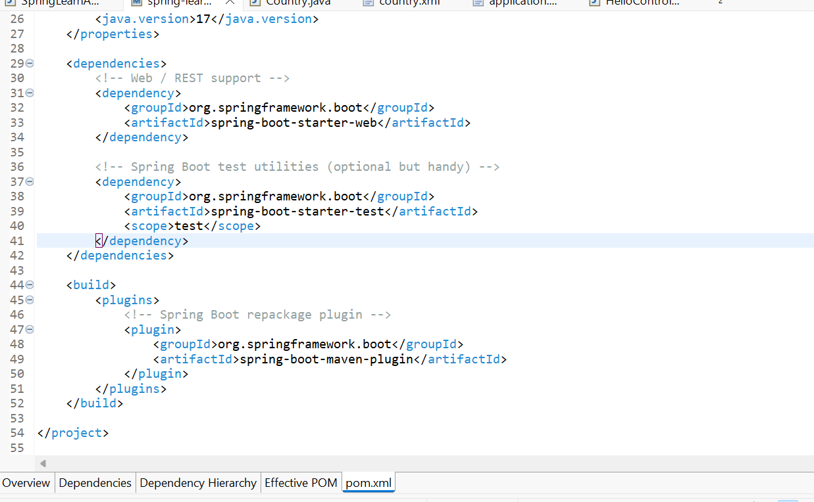

4) application.properties:

spring.application.name=spring-learn

logging.level.root=DEBUG

server.port=8083

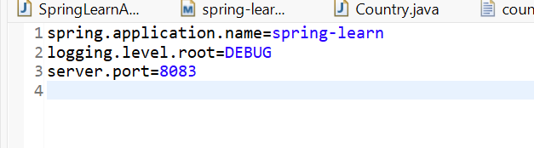

Output:

Browser:

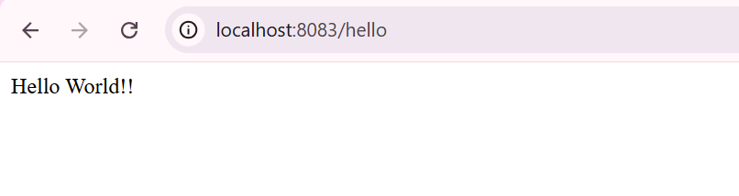

Postman:

